CSE 4571 – PRACTICAL ROBOTICS PROJECTS WITH ARDUINO
EXPERIMENT 6
NON-BLOCKING DC MOTOR CONTROL USING A FINITE STATE MACHINE
Duration | Level | Mode | CO Mapping
2 Hours | B.Tech CSE Final Year | Hardware / Wokwi* | CO3, CO5
1. Aim of the Experiment
To implement a responsive robotic controller using an HC-SR04 distance sensor, a DC motor, a pushbutton and a buzzer, with a finite state machine and millis()-based timing.
2. Objectives
- Model robotic behavior using explicit states and transitions.
- Use millis() for elapsed-time control rather than long blocking delays.
- Control a DC motor safely through a transistor switching stage.
- Use HC-SR04 distance as an event that changes the controller state.
- Generate an audible alert when the detected distance falls below the threshold.
3. Important Hardware Note
An Arduino UNO GPIO pin must not drive a DC motor directly. The motor is therefore controlled through an NPN transistor as a low-side switch. In a physical circuit, place a flyback diode across the motor and use a suitable motor supply; connect the motor-supply ground to Arduino GND. The diagram intentionally shows the switching stage so beginners do not connect the motor directly to D6.
4. Components / Wokwi Parts
Component | Qty. | Purpose
Arduino UNO | 1 | Controller
HC-SR04 | 1 | Distance sensing
DC motor | 1 | Actuator
NPN transistor | 1 | Motor switching
Flyback diode* | 1 | Motor protection
Pushbutton | 1 | Start event
Buzzer | 1 | Alert output
Motor supply* | 1 | Motor power
5. Circuit Connections
Signal / Component | Pin / Point | Connection Detail
HC-SR04 TRIG | D9 | Trigger pulse
HC-SR04 ECHO | D10 | Echo input
Motor control | D6 | NPN base via base resistor
NPN collector | Motor − | Low-side switching
NPN emitter | GND | Common ground
Motor + | Motor supply + | External supply recommended
Pushbutton | D2 → GND | INPUT_PULLUP
Buzzer + | D7 | Alert output
Buzzer − | GND | Common ground
HC-SR04 VCC | 5V | Sensor supply
HC-SR04 GND | GND | Common ground
6. Theory
A finite state machine divides control into discrete states. This experiment uses IDLE, RUN and ALERT. The pushbutton starts RUN. During RUN the DC motor is ON while the controller checks the HC-SR04. If distance becomes less than 20 cm, the controller enters ALERT, switches the motor OFF and activates the buzzer. When the object is at least 20 cm away and the alert has lasted more than 1 second, the controller returns to RUN. millis() provides elapsed-time control without long delay() calls.
7. State Model
State | Transition | Motor | Buzzer | Purpose
IDLE | Button pressed → RUN | OFF | OFF | Waiting
RUN | <20 cm → ALERT; >8 s → IDLE | ON | OFF | Normal operation
ALERT | ≥20 cm and >1 s → RUN | OFF | 1800 Hz | Hazard response
8. Pre-Lab Questions
- Why must a DC motor not be connected directly to an Arduino GPIO pin?

- What is the purpose of a transistor motor switch?

- What is an FSM?

- Why is millis() useful in responsive robotic control?

8. Procedure
- Build the circuit exactly as shown.
- Verify that the motor is connected through the transistor switch, not directly to D6.
- Run the program and open Serial Monitor.
- Press the pushbutton to start RUN.
- Observe the motor running.
- Place an object below 20 cm from the HC-SR04.
- Observe ALERT: motor OFF and buzzer ON.
- Move the object away and observe return to RUN.
- Record state, distance condition, motor and buzzer status.

9. Circuit Diagram
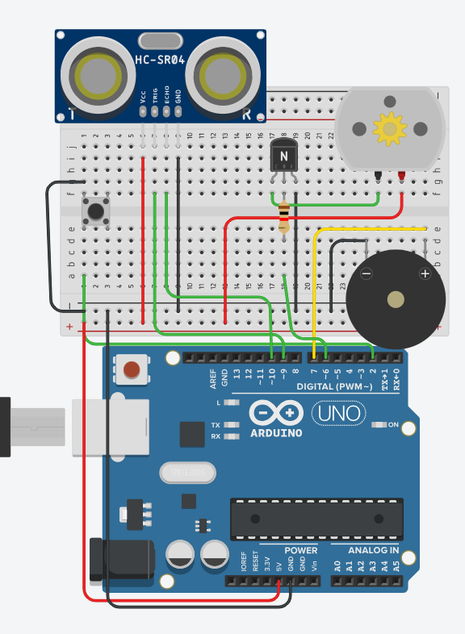
Figure 1. Verified HC-SR04–DC motor–button–buzzer FSM controller with transistor switching.
10. Hardware Implementation

11. Arduino Program

12. Observation Table
Sl. No. | Distance Condition | FSM State | DC Motor | Buzzer
1
2
3
4
5
6
13. Expected Output / Analysis
Power-up starts in IDLE with motor and buzzer OFF. Button press changes to RUN and switches the motor ON. Distance below 20 cm changes to ALERT, where the motor is OFF and the buzzer sounds at 1800 Hz. When distance is at least 20 cm and ALERT has lasted over 1 second, the controller returns to RUN. If RUN lasts over 8 seconds without ALERT, it returns to IDLE.
14. Result
A non-blocking FSM controller was implemented with HC-SR04 sensing, DC motor actuation through a transistor switch, pushbutton input and buzzer alerting, using millis()-based state timing.
15. Post-Lab Questions
- Add a PAUSE state in which the motor is OFF while sensing continues.

- Make RUN return to IDLE after 5 seconds.

- Add PWM and a SLOW state.

16. Precautions
- Never drive the DC motor directly from an Arduino digital pin.
- Use an appropriate transistor and base resistor.
- Use a flyback diode across the motor in physical hardware.
- Use a suitable motor supply and common the grounds.
- Verify all pin assignments before powering the circuit.
- The delayMicroseconds() calls only generate the HC-SR04 trigger pulse; state timing uses millis().
17. Suggested Extension
Implement PWM speed control with a SLOW state and document the revised state-transition diagram.

18. Student Record

Student Name | Registration No. | Date | Faculty Signature

